Name:________Andrew Rohn__________
CMIS 310
HOMEWORK #5 – Week #5

This homework is worth 10% of your course grade.

Read each problem carefully. Failure to follow the instructions for a problem will result in a zero score for that problem.

Submit the completed Homework via Assignment in LEO.

- Do Exercise 2 in Chapter 6 (Memory) of Null and Lobur
Suppose a computer using direct mapped cache has 2³² words of main memory and a cache of 1024 blocks, where each cache block contains 32 words.
  - How many blocks of main memory are there?

$$\frac{2^{32} word of main memory}{2^{5} words per block}=2^{27} blocks$$

  - What is the format of a memory address as seen by the cache, that is, what are the sizes of the tag, block, and word fields?

$$32-bit addresses comprimising of:$$
$$17 bits for the tag field$$
$$10 bits for the block field$$
$$5 bits for the word field$$

  - To which cache block will the memory reference 000063FA₁₆ map?

$$Binary value of 000063FA: 00000000000000000 1100011111 11010$$
$$Unsigned Decimal value of 1100011111 :799$$
$$So, Block 799$$

- Do Exercise 4 in Chapter 6 (Memory) of Null and Lobur
Suppose a computer using fully associative cache has 2²⁴ words of main memory and a cache of 128 blocks, where each cache block contains 64 words.
  - How many blocks of main memory are there?

$$\frac{2^{24} word of main memory}{2^{6} words per block}=2^{18} blocks$$

  - What is the format of a memory address as seen by the cache, that is, what are the sizes of the tag and word fields?

$$24-bit addresses comprimising of:$$
$$18 bits for the tag field$$
$$6 bits for the word field$$

  - To which cache block will the memory reference 01D872₁₆ map?

$$It can map to any cache block because it is using fully associative cache.$$

- Do Exercise 6 in Chapter 6 (Memory) of Null and Lobur
A 2-way set associative cache consists of four sets. Main memory contains 2K blocks of eight words each.
  - Show the main memory address format that allows us to map addresses from main memory to cache. Be sure to include the fields as well as their sizes.

$$2K blocks*8 words each= 2^{11}* 2^{3}=2^{14}=14-bit addresses$$

$$14-bit addresses comprimising of:$$
$$9 bits for the tag field$$
$$2 bits for the set field (since there are 2^{2} sets)$$
$$3 bits for the word field$$

  - Compute the hit ratio for a program that loops 3 times from locations 8 to 51 in main memory. You may leave the hit ratio in terms of a fraction.

First Loop:

1) Location 8 is a miss
2) Block moves to set 1, 9 to 15 are hits
3) Location 16 is a miss
4) Block moves to set 2, 17 to 23 are hits
5) Location 24 is a miss
6) Block moves to set 3, 25 to 31 are hits
7) Location 32 is a miss
8) Block moves to set 0, 33 to 39 are hits
9) Location 40 is a miss
10) Block moves to set 1, 41 to 47 are hits
11) Location 48 is a miss
12) Block moves to set 2, 49 to 51 are hits

Result: 6 misses and 38 hits

Second & Third Loops:

Result: All hits, so 0 misses and 88 (44*2) hits

So for all loops, we have a total of 6 misses and 126 (38+88) hits.
Hit Ratio = 126/132 or 95.45%

- Do Exercise 8 in Chapter 6 (Memory) of Null and Lobur
Suppose a computer using set associative cache has 2²¹ words of main memory and a cache of 64 blocks, where each cache block contains 4 words.
  - If this cache is 2-way set associative, what is the format of a memory address as seen by the cache, that is, what are the sizes of the tag, set, and word fields?

$$2^{21} words of main memory=21-bit addresses$$

$$\frac{cache of 2^{6} blocks}{2^{1} blocks per set}=2^{5} sets=5 bits for set field$$

$$21-bit adresses comprimising of:$$
$$14 bits for the tag field$$
$$5 bits for the set field$$
$$2 bits for the word field$$

  - If this cache is 4-way set associative, what is the format of a memory address as seen by the cache?

$$\frac{cache of 2^{6} blocks}{2^{2} blocks per set}=2^{4} sets=4 bits for set field$$

$$21-bit adresses comprimising of:$$
$$15 bits for the tag field$$
$$4 bits for the set field$$
$$2 bits for the word field$$

- Do Exercise 12 in Chapter 6 (Memory) of Null and Lobur
Suppose a process page table contains the entries shown below. Using the format shown in Figure 6.15a, indicate where the process pages are located in memory.
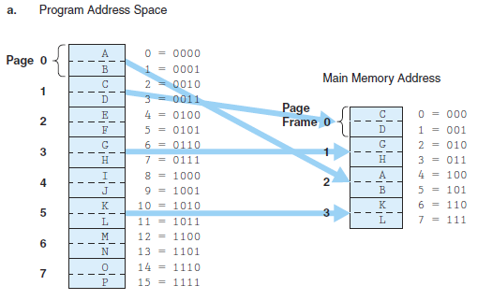

Frame | Valid bit
1 | 1
- | 0
0 | 1
3 | 1
- | 0
- | 0
2 | 1
- | 0

Figure 6.15a
The text of exercises and similar solved exercises are on the topic Books24x7 Readings:
http://library.books24x7.com.ezproxy.umuc.edu/assetviewer.aspx?site=VGX8U&bookid=5893&chunkid=188441613

Program Address Space Main Memory Address

0 0

1 1

2 2

3 3

4

5

6

7

